SYDNEY WESTERN CITY PLANNING PANEL

Panel No: | PPSSWC-48
DA Number: | DA/2019/987/1
Local Government Area: | Camden
Proposed Development: | Construction of a new two-storey school building at Oran Park Anglican School
Capital Investment Value: | $5,271,276
Street Address(es): | 60 Central Avenue, Oran Park  Lot: 15 DP: 1153031
Applicant: | Warren Fletcher – Gardner Wetherill Butler and Co Architects
Owner: | The Anglican Schools Corporation
Number of Submissions: | Nil
Recommendation: | Approve with conditions
Regional Development Criteria (Schedule 7 of State Environmental Planning Policy (State and Regional Development) 2011): | Private infrastructure or community facility over $5 million
List of All Relevant s4.15(1)(a) Matters: | - State Environmental Planning Policy (State and Regional Development) 2011.  - State Environmental Planning Policy (Educational Establishments and Child Care Facilities) 2017.  - State Environmental Planning Policy (Sydney Region Growth Centres) 2006 (Growth Centres SEPP).  - State Environmental Planning Policy No 64 – Advertising and Signage.  - State Environmental Planning Policy No 55 - Remediation of Land.  - Sydney Regional Environmental Plan No 20 - Hawkesbury-Nepean River.
Does the DA Require Special Infrastructure Contributions Conditions (s7.24)? | Yes.
List all Documents Submitted with this Report for the Panel’s Consideration: | - Assessment report.  - State Environmental Planning Policy (Sydney Region Growth Centres) 2006 Assessment Table.  - Recommended conditions.  - Site photos.  - RMS response.  - Proposed plans.
Report Prepared By: | Hannah Draper, Town Planner
Report Date: | April 2020

Summary of Section 4.15 Matters

Yes
Have all recommendations in relation to relevant Section 4.15 matters been summarised in the Executive Summary of the assessment report?

Legislative Clauses Requiring Consent Authority Satisfaction

Yes
Have relevant clauses in all applicable environmental planning instruments where the consent authority must be satisfied about a particular matter been listed and relevant recommendations summarised in the Executive Summary of the assessment report?

Development Standard Contraventions

 | Yes | N/A
If a written request for a contravention to a development standard has been received, has it been attached to the assessment report?

Special Infrastructure Contributions

 | Yes | No
Does the application require Special Infrastructure Contributions?

Conditions

 | Yes | No
Have draft conditions been provided to the applicant for comment?

PURPOSE OF REPORT

The purpose of this report is to seek the Sydney Western City Planning Panel’s (The Panel’s) determination of a development application (DA) for a school building at 60 Central Avenue, Oran Park.

The Panel is the consent authority for this DA as the capital investment value (CIV) of the development is $5,271,276. This exceeds the CIV threshold of $5 million for private infrastructure or community facilities for Council to determine the DA pursuant to Schedule 7 of State Environmental Planning Policy (State and Regional Development) 2011.

SUMMARY OF RECOMMENDATION

That the Panel determine DA/2019/987/1 for a school building pursuant to Section 4.16 of the Environmental Planning and Assessment Act 1979 by granting consent subject to the conditions attached to this report.

EXECUTIVE SUMMARY

Council is in receipt of a DA for school building at 60 Central Avenue Oran Park.

The DA has been assessed against the Environmental Planning and Assessment Act 1979, the Environmental Planning and Assessment Regulation 2000, relevant environmental planning instruments, development control plans and policies.

A summary of the assessment of all relevant environmental planning instruments is provided below with a detailed assessment provided later in the report.

State Environmental Planning Policy (State and Regional Development) 2011. | The Panel is the determining authority for this DA as the proposed development has a CIV of $5,271,276 which exceeds the CIV threshold of $5 million for Council to determine the DA.
State Environmental Planning Policy (Educational Establishments and Child Care Facilities) 2017 | The proposed development is permissible under the SEPP. The new school building has a high quality design and architectural presence that is in accordance with the design principles prescribed under Schedule 4 of the SEPP and are found to be satisfactory.  Referral to Transport for NSW (RMS) was not necessary pursuant to clause 57 of the SEPP as there is no increase to the number of students, staff and car parking. However, Transport for NSW were notified given the proximity of works to Peter Brock Drive. Transport for NSW (RMS) responded advising that there is no objection to the proposed development as it is unlikely to have an impact on the surrounding classified road network.
State Environmental Planning Policy (Sydney Region Growth Centres) 2006. | The proposed development is permitted with consent in the applicable R3 Medium Density Residential zone. The proposed development is further consistent with the zones objectives and is compliant with the controls of the SEPP subject to recommended conditions where necessary.
State Environmental Planning Policy No 64 – Advertising and Signage | The signage is consistent with SEPP 64’s objectives in that it is compatible with the desired amenity and visual character of the area, will provide effective communication by displaying the schools name and logo and will be of a high quality design and finish that is appropriate the area.
State Environmental Planning Policy No 55 - Remediation of Land. | Clause 7 of SEPP 55 requires the consent authority to consider if the site if contaminated. If the site is contaminated, the consent authority must be satisfied that it is suitable in its contaminated state for the development.  Council staff have previously assessed contamination for the existing school under DA/2012/927/1 where a phase 2 contamination assessment was provided. The contamination assessment concluded that no contaminants of concern were present and therefore the land is suitable for the proposed development.
Sydney Regional Environmental Plan No 20 - Hawkesbury-Nepean River (SREP). | The development is consistent with the aim of SREP 20 (to protect the environment of the Hawkesbury-Nepean River system) and all of its planning controls.

The DA was publicly exhibited for a period of 14 days in accordance with Camden Development Control Plan 2019. The exhibition period was from 15 January 2020 to 28 January 2020. No submissions were received.

The proposed development has been assessed against the State Environmental Planning Policy (Educational Establishments and Child Care Facilities) 2017, State Environmental Planning Policy (Sydney Region Growth Centres) 2006, Oran Park Development Control Plan 2007 and Camden Development Control Plan 2019. The development is consistent with these planning policies and controls.

The Education SEPP requires that any provision of a development control plan (such as the Camden DCP 2019 and Oran Park DCP 2007) has no effect, regardless of when the development control plan was made. Therefore, the controls of the Camden DCP 2019 and Oran Park DCP 2007 do not apply to the site. However, it is noted that the proposal is consistent with the objectives and controls contained within both DCPs subject to recommended conditions.

The proposed development does not propose a change to the existing approved staff/student numbers for the school. The maximum number remains consistent with the masterplan consent being 986 students and 75 staff.

Given there is no increase to the number of staff or students, no additional car parking is required as part of this development. It is noted that car parking will need to be provided in future applications as identified in the car parking staging plan approved under the Master Plan concept DA/2012/927/1.

The applicant has submitted an adequate stormwater concept plan and that, subject to the attached conditions, will provide appropriate levels of onsite detention and water sensitive urban design outcomes.

Based on the assessment, it is recommended that the DA be approved subject to the recommended conditions attached to this report.

AERIAL PHOTO

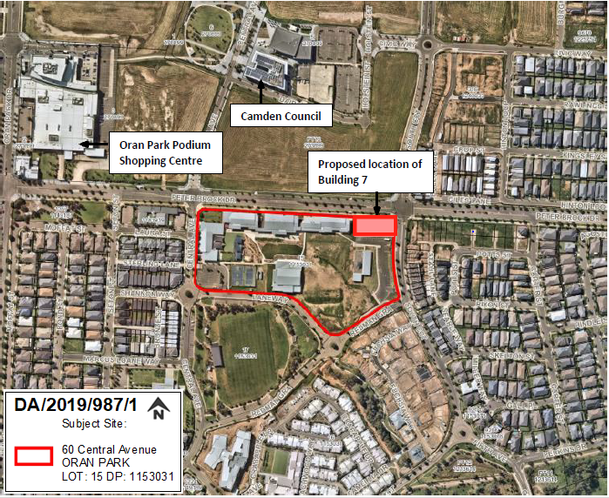
Figure 1: Aerial Photo and Surrounding Context

THE SITE

The subject site is commonly known as Oran Park Anglican College and is located at 60 Central Avenue Oran Park. The site is legally described as Lot: 15 DP: 1153031.

The school site is centrally located within the Oran Park Precinct nearby Oran Park Town Centre. The site is adjacent to land zoned for retail, leisure, civic, residential and mixed-use purposes. The site is bound by Peter Brock Drive to the north, South Circuit to the east, Shannon Way to the south and Central Avenue to the west. Existing access to the site is provided from Central Avenue and Shannon Way.

Within the school site, Building 7 is proposed to be located on the north-eastern corner with direct frontage to Peter Brock Drive and South Circuit. The land slopes downward along Peter Brock Drive from Central Avenue to South Circuit with a fall of approximately 3 metres along the entire length of the proposed building.

The site is zoned as R3 – Medium Density Residential under State Environmental Planning Policy (Sydney Region Growth Centres) 2006 – Appendix 1 Oran Park & Turner Road Precinct Plan (the Growth Centres SEPP). The proposed new building does not alter the existing use on site as an educational establishment.

ZONING PLAN

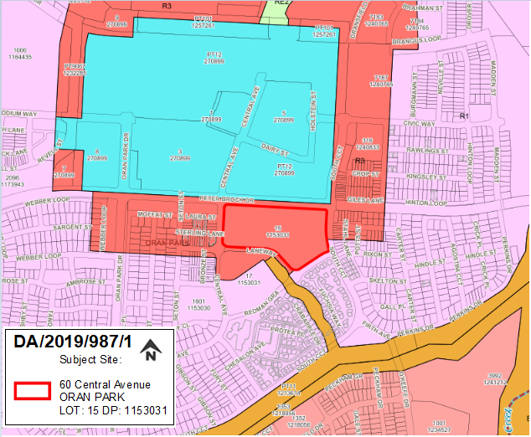
Figure 2: Land Zoning Map – R3 – Medium Density Residential

MASTERPLANS

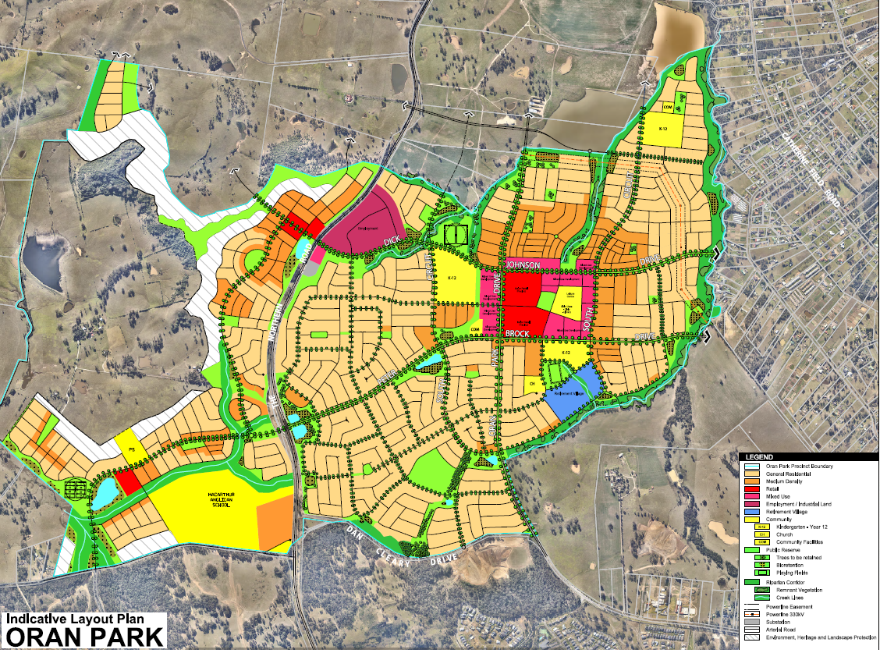
Figure 3: Oran Park Indicative Layout Plan

BACKGROUND

The relevant development background of the site is summarized in the table below:

Application No. | Development
DA/2007/982/1 | Creation of the subject site as a residue lot.
DA/2010/680/1 | Approval of the primary school campus for the Oran Park Anglican College (for 120 students and 9 staff from K to Year 3), including the construction of 33 parking spaces.
DA/2010/680/(2) | Modification to allow the operation of the school up to Year 6, with no increase to approved student numbers.
DA/2010/680/(3) | Modification to allow the operation of the school up to Year 7 with an increase of staff to 11 and installation of six temporary demountable classrooms for 2 years.
DA/2010/680/(4) | Modification to relocate the six demountable classrooms.
DA/2012/927/1 | Approval of a staged development for the primary and secondary school for the Oran Park Anglican College (for 986 students). The DA also approved the construction of “Building 2A”, playground, stormwater detention, and road works.
DA/2015/1394/1 | Construction of a two storey school building including landscaping. The DA involved the construction of “Building 4” in accordance with the approved staged development consent (DA 927/2012). The proposal is in accordance with the approved masterplan as part of the staged consent.
DA/2016/1164/1 | Construction of the multi-purpose hall (Building 9), no increase in student numbers or car parking was associated with this development.
DA/2017/1250/1 | Construction of a new two storey school building (Building 3) incorporating classrooms, staff and student services.

The subject land has been approved for the staged development of a Kindergarten to Year 12 educational establishment.

Previous development application DA/2010/680/1 was approved for the primary school campus of the Oran Park Anglican College, which included the construction of four (4) primary school classrooms, six (6) temporary demountable buildings, carpark, drop-off area, playground and support facilities.

A further development application was approved under DA/2012/927/1 for the staged development of the high school campus of the Oran Park Anglican College. The consent approved a Master Plan which specified that separate development applications are to be lodged for each stage. The consent approved the staged concept development of the school as well as the construction of Building 2A and a playground.

Since the approval of the staged Master Plan, the school site has undergone orderly development generally in accordance with the approved Master Plan for the site.

The proposed development remains in accordance with Section 4.22 of the Environmental Planning and Assessment Act 1979 in that is it conforms to the “concept development application” master plan approved under DA/2012/927/1.

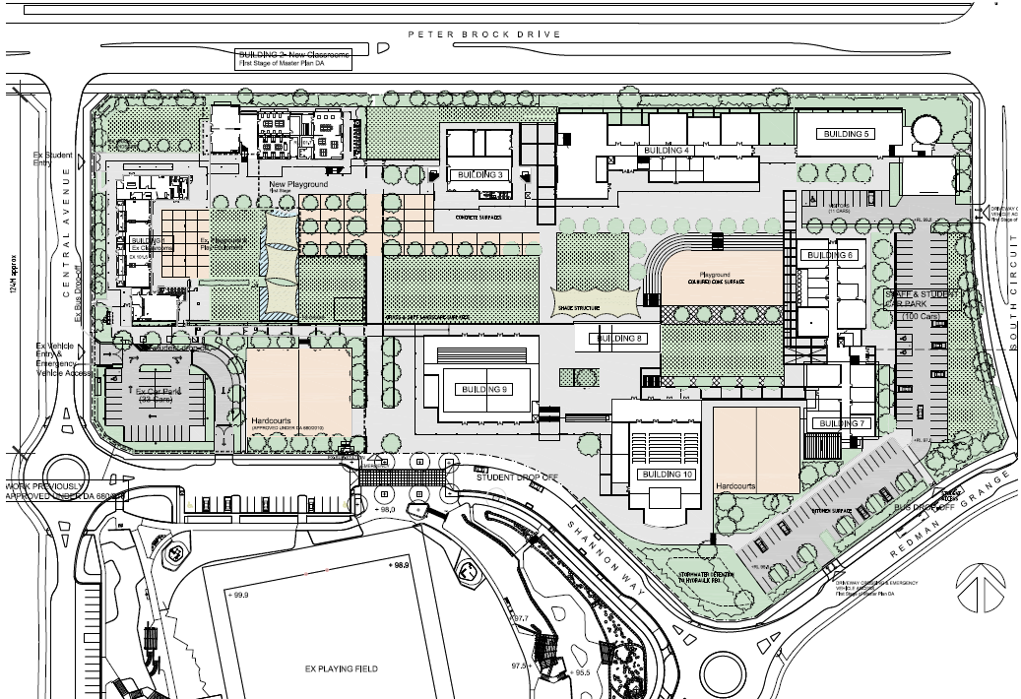
Figure 4: Master Plan approved under DA/2019/927/1

THE PROPOSAL

The application is seeking approval for the construction of a new two storey school building comprising of classrooms and specialist classrooms at Oran Park Anglican College. Specifically, this includes:

- The ground floor comprises of student bathrooms at the western end, two technology classrooms with tech labs, two general learning areas (GLA’s), a break out space adjoining a dedicated Year 12 meeting and a study area at the eastern end of the building.

- At the first-floor level there are 4 x GLA’s adjoining a central breakout area and two science labs with prep area and chemistry storeroom at the eastern end of the building.

- A covered outdoor area on the southern side of the building with stair access to the covered verandah at the first floor. A bridge link will connect the proposed building to existing Building 3.

- Landscaping along Peter Brock Drive and South Circuit, drainage and associated site works.

- Stone block school identification signage panel (1800h) with cut out lettering and school logo.

- The new school building is generally similar in dimensions, setback and built form to the existing school buildings on the site fronting Peter Brock Drive. The modulated façade and selection of colours and materials complements the character of the existing school-built form.

- The proposed new school classroom building is generally in the location of Building 5 in the approved staged Master Plan works under DA/2012/927/1. It is noted that the Master Plan refers to the developable area as Building 5. This application has referred to it as Building 7, which aligns with the order of works undertaken to date.

The proposed development has an estimated CIV of $5.2 million.

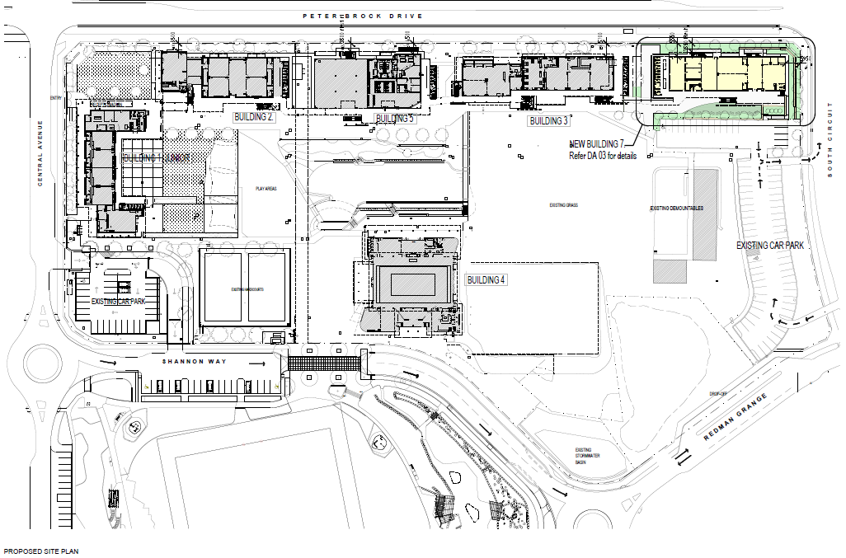
Figure 5: Site Plan
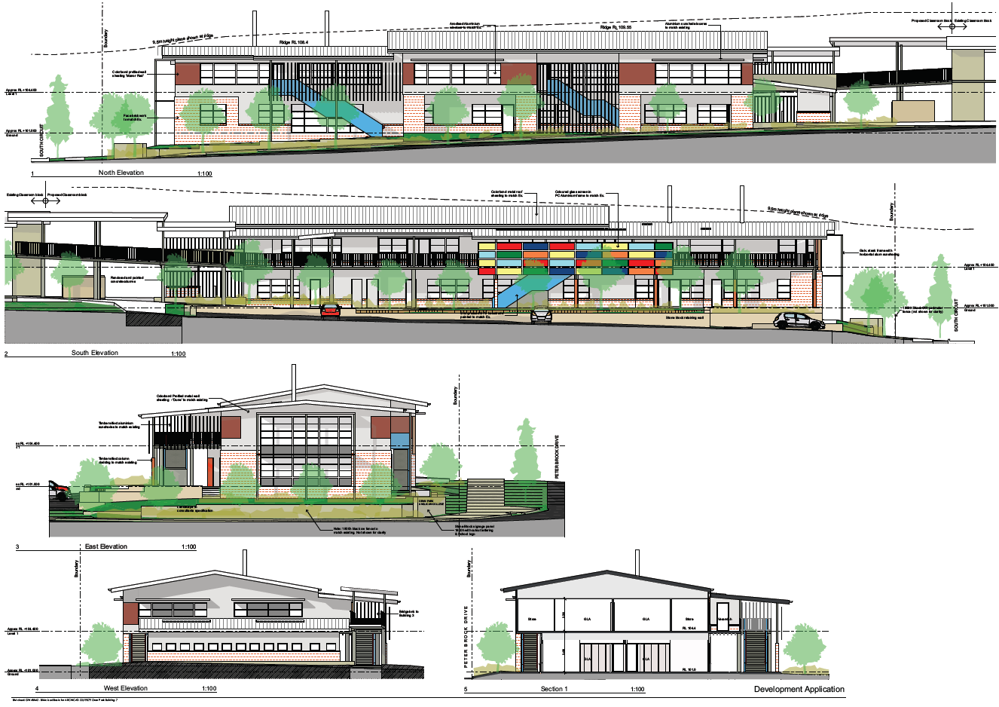
Figure 6: Elevations, Section and External Finishes
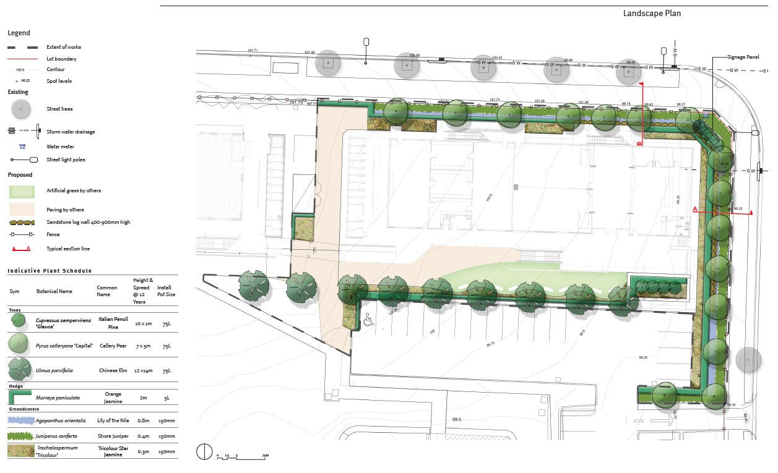
Figure 7: Landscape Plan

PANEL BRIEFING

Council staff briefed the Panel on the DA on 6 February 2020. The following discussion provides an assessment of how the issues raised by the Panel at the briefing have been addressed:

- Corner treatment – Filling of the corner

It is noted that sections were provided depicting how interface with the street would be managed. Council staff have assessed the level of fill and consider it acceptable.

The natural slope of the land necessitates the level of fill proposed to create a level building platform. The applicant has proposed a stepped retaining wall design around the eastern perimeter of the development site which will stagger the amount of fill and soften the level change. Further, high quality landscaping has been proposed which achieve a desirable streetscape presence. Overall, it is considered that a reasonable balance has been achieved between managing the natural slope of the land and achieving an attractive, articulated and landscaped frontage.

ASSESSMENT

Environmental Planning and Assessment Act 1979 – Section 4.15(1)

In determining a DA, the consent authority is to take into consideration such of the following matters as are of relevance to the development the subject of the DA:

(a)(i) the provisions of any environmental planning instrument

The environmental planning instruments that apply to the proposed development are:

- State Environmental Planning Policy (State and Regional Development) 2011.
- State Environmental Planning Policy (Sydney Region Growth Centres) 2006.
- State Environmental Planning Policy (Educational Establishments and Child Care Facilities) 2017.
- State Environmental Planning Policy No 64 – Advertising and Signage.
- State Environmental Planning Policy No 55 – Remediation of Land.
- Sydney Regional Environmental Plan No 20 – Hawkesbury-Nepean River.

State Environmental Planning Policy (State and Regional Development) 2011 (SRD SEPP)

The SRD SEPP identifies development that is State significant or regionally significant development.

Pursuant to Schedule 7 of the SEPP, the Panel is the determining authority for this DA as the proposed development has a CIV of $5,271,276 which exceeds the CIV threshold of $5 million (private infrastructure or community facility) for Council to determine the DA.

State Environmental Planning Policy (Sydney Region Growth Centres) 2006 (Growth Centres SEPP)

The Growth SEPP aims to co-ordinate the release of land for residential, employment and other urban development in the North West Growth Centre, the South West Growth Centre and the Wilton Growth Area.

Site Zoning

The development site is zoned R3 Medium Density Residential pursuant to Appendix 1, Clause 2.2 of the Growth Centres SEPP.

Land Use Definitions

The proposed development is defined as an “educational establishment”” by the Growth Centres SEPP.

Permissibility

The proposed development is permitted with consent in the R3 zone pursuant to the land use table in Appendix 1 of the Growth Centres SEPP.

An assessment table in which the proposed development is considered against the Growth Centres SEPP is provided as an attachment to this report.

State Environmental Planning Policy (Educational Establishments and Child Care Facilities) 2017.

The Education SEPP applies to the subject development being for the purpose of a ‘school’. Part 4 of the Education SEPP outlines the development controls for schools where development is permitted with consent. Under the provisions of Clause 35(3) the proposed new school building within the boundaries of the existing school are permitted with development consent.

With reference to Clause 35(6)(a) of the SEPP, the proposed development has been assessed against the design principles set out under Schedule 4 of the SEPP. The new school building has a high-quality design and architectural presence that is compliant with the design principles prescribed under Schedule 4. Based on this assessment the proposal has adequately complied with this clause.

State Environmental Planning Policy (Educational Establishments and Child Care Facilities) 2017 (Education SEPP) – Schedule 4
Principle 1—context, built form and landscape
Schools should be designed to respond to and enhance the positive qualities of their setting, landscape and heritage, including Aboriginal cultural heritage. The design and spatial organisation of buildings and the spaces between them should be informed by site conditions such as topography, orientation and climate.  Landscape should be integrated into the design of school developments to enhance on-site amenity, contribute to the streetscape and mitigate negative impacts on neighbouring sites.  School buildings and their grounds on land that is identified in or under a local environmental plan as a scenic protection area should be designed to recognise and protect the special visual qualities and natural environment of the area, and located and designed to minimise the development’s visual impact on those qualities and that natural environment. | The development has been proposed having regard to its locational setting, surrounding landscape and heritage. It is noted that the subject site is not identified as having a heritage items nor is located adjacent to a heritage item. The original DA was issued with an AHIP and standard conditions shall apply in relation to any unexpected finds.  The landscaping proposed has helped manage the fall in levels on South Circuit. The applicant has proposed staggered retaining walls to soften the level change as well as landscaping around the eastern corner of the site. The proposed planting includes trees, shrubs and turf which have been incorporated into the building frontages to soften the built form and improve the streetscape. The landscaping proposed has been designed to utilise the sites orientation to ensure climatic opportunities are maximised. The landscaping further responds to the desired building footprint by articulating the developments key corner site location. Overall, the site presents as an attractive, articulated and well landscaped development when viewed at a streetscape level.  The subject site is not identified as being a scenic protection area. Notwithstanding, the proposed development does not unduly impact on the visual qualities or natural environment. The building works are considered modest and will assist in complementing the visual character and aesthetics of the existing school site.
Principle 2—sustainable, efficient and durable
Good design combines positive environmental, social and economic outcomes. Schools and school buildings should be designed to minimise the consumption of energy, water and natural resources and reduce waste and encourage recycling.  Schools should be designed to be durable, resilient and adaptable, enabling them to evolve over time to meet future requirements. | The building has been designed to incorporate sustainable building design principles. The proposed school building utilises natural ventilation and shading devices to control solar access and maximise the buildings orientation.  The building itself is constructed of durable materials and the shape of the building allows for there to be flexibility around the use of the room. It is considered that the building is capable of accommodating adaptable learning typologies.
Principle 3—accessible and inclusive
School buildings and their grounds should provide good wayfinding and be welcoming, accessible and inclusive to people with differing needs and capabilities.  Note. Wayfinding refers to information systems that guide people through a physical environment and enhance their understanding and experience of the space.  Schools should actively seek opportunities for their facilities to be shared with the community and cater for activities outside of school hours. | The proposal provides clear pathways for intuitive navigation across the site. The paths proposed provide equitable access and connect to other key pathways within the school grounds. The the first-floor pedestrian bridge connects to the existing Building 3 to the east allowing for ease of access.  School identification signage is proposed under this application and existing signage is evident within the existing campus to assist with wayfinding from external members as well as students, staff, parents and visitors frequenting the campus
Principle 4—health and safety
Good school development optimises health, safety and security within its boundaries and the surrounding public domain, and balances this with the need to create a welcoming and accessible environment. | Pathways to outdoor spaces and between school buildings is equitable and is provided without any hazards. The landscape design staggers the level changes to ensure pathways are safe with no steep grades. The site has a security fence to the property boundary and access to the site is controlled through central entrances.  The proposed building fronts Peter Brock Drive and South Circuit. It incorporates various windows fronting each road providing passive street surveillance. The building will also provide appropriate surveillance within the site and surrounds. DA/1394/2015 was referred to Camden Local Area Command, who stated on 17 February 2016, the overall design poses a “low crime risk”. It is considered the subject proposal will pose a low crime risk also as it is ancillary to the use as an education establishment.
Principle 5—amenity
Schools should provide pleasant and engaging spaces that are accessible for a wide range of educational, informal and community activities, while also considering the amenity of adjacent development and the local neighbourhood.  Schools located near busy roads or near rail corridors should incorporate appropriate noise mitigation measures to ensure a high level of amenity for occupants.  Schools should include appropriate, efficient, stage and age appropriate indoor and outdoor learning and play spaces, access to sunlight, natural ventilation, outlook, visual and acoustic privacy, storage and service areas. | It is not considered that there will be any undue impacts to the amenity of adjoining developments. The use of the site as an educational facility and the potential impacts to surrounding residential development has already been assessed under DA/2012/927/1.  The proposed school building is located along Peter Brock Drive which is a four lane sub arterial road. In this regard, Councils Specialist Support Environmental Health Officer has recommended a condition of consent for internal noise compliance. This approach was based on the provision of an acoustic assessment for the masterplan where it was found that only road traffic noise intrusion would be an issue for the school. A condition has been applied requiring internal noise compliance to be demonstrated at the construction certificate stage.  The indoor learning space is considered appropriate for its intended use as technology classrooms, tech labs and general learning areas. The shape and size of the room is an efficient use of the space. The building is oriented to the north east orientation allowing for sunlight and natural ventilation to be optimized.
Principle 6—whole of life, flexible and adaptive
School design should consider future needs and take a whole-of-life-cycle approach underpinned by site wide strategic and spatial planning. Good design for schools should deliver high environmental performance, ease of adaptation and maximise multi-use facilities. | The shape of the building footprint allows for adaptable learning environments with the ability to expand and offer multi-use functions over time if needed.
Principle 7—aesthetics
School buildings and their landscape setting should be aesthetically pleasing by achieving a built form that has good proportions and a balanced composition of elements. Schools should respond to positive elements from the site and surrounding neighbourhood and have a positive impact on the quality and character of a neighbourhood.  The built form should respond to the existing or desired future context, particularly, positive elements from the site and surrounding neighbourhood, and have a positive impact on the quality and sense of identity of the neighbourhood. | The new school building is generally similar in dimensions, setback and built form to the existing school buildings on the site fronting Peter Brock Drive. The modulated façade and selection of colours and materials complements the character of the existing school-built form.  Similarily, the landscaping works are considered appropriate

Clause 35(6)(b) requires the consent authority to consider whether the development enables the use of the school facilities (including recreational facilities) to be shared with the community. The proposed school building is primarily for the use of the school to carry out teaching and educational functions. However, the existing site as a whole provides the opportunity for community use due to its recreational grounds and general assembly area. The proposed building will not reduce or inhibit the ability of the community to utilise the school for community purposes.

Clause 35(9) of the SEPP requires that any provision of a development control plan (such as the Camden DCP 2019 and Oran Park DCP 2007) has no effect, regardless of when the development control plan was made. Therefore, the controls of the Camden DCP 2011 and Oran Park DCP 2007 do not apply to the development.

Referral to Transport for NSW (RMS) was not necessary pursuant to clause 57 of the SEPP as there is no increase to the number of students, staff and car parking. However, Transport for NSW (RMS) were notified given the proximity of works to Peter Brock Drive. Transport for NSW (RMS) responded advising that there is no objection to the proposed development as it is unlikely to have an impact on the surrounding classified road network.

State Environmental Planning Policy No 64 – Advertising and Signage

SEPP 64 aims to ensure that signage is compatible with the desired amenity and visual character of the area, provides effective communication in suitable locations and is of high quality design and finish.

Clause 8 of SEPP 64 requires the consent authority to be satisfied that signage is consistent with the objectives of SEPP 64 and the assessment criteria specified in Schedule 1.

Council staff are satisfied that the signage is consistent with SEPP 64’s objectives in that it is compatible with the desired amenity and visual character of the area, will provide effective communication by displaying the schools name and logo and will be of a high quality design and finish that is appropriate the area.

SEPP 64 – Advertising and Signage
Schedule 1

1 Character of the area
Is the proposal compatible with the existing or desired future character of the area or locality in which it is proposed to be located? | The site is zoned R3 – Medium Density Residential. The signage is of an appropriate size and is compatible with the existing and desired future character of the area as it identifies the use of the site and the schools name.
Is the proposal consistent with a particular theme for outdoor advertising in the area or locality? | The proposed signage is consistent with the existing school signage located on Central Avenue and Peter Brock Drive.
2 Special areas
Does the proposal detract from the amenity or visual quality of any environmentally sensitive areas, heritage areas, natural or other conservation areas, open space areas, waterways, rural landscapes or residential areas? | The proposed signage will not adversely impact on the visual character of the area as only one sign is visible from the public domain.
3 Views and vistas
Does the proposal obscure or compromise important views? | No, the proposed signage will not obscure or compromise views.
Does the proposal dominate the skyline and reduce the quality of vistas? | No, the proposed signage will not dominate the skyline or reduce the quality of vistas.
Does the proposal respect the viewing rights of other advertisers? | The proposed signage will not obscure or detract from existing views to nearby signs.
4 Streetscape, setting or landscape
Is the scale, proportion and form of the proposal appropriate for the streetscape, setting or landscape? | All signage is considered reasonable and proportional to the buildings scale.
Does the proposal contribute to the visual interest of the streetscape, setting or landscape? | The signage will assist in the public being able to identify the school. It is appropriately integrated into the building’s frontage and landscaping.
Does the proposal reduce clutter by rationalising and simplifying existing advertising? | The proposal is not considered to create clutter.
Does the proposal screen unsightliness? | The building does not display unsightliness.
Does the proposal protrude above buildings, structures or tree canopies in the area or locality? | The signage does not protrude above buildings, structures or trees in the locality.
Does the proposal require ongoing vegetation management? | The proposed signage will not require ongoing vegetation management.
5 Site and building
Is the proposal compatible with the scale, proportion and other characteristics of the site or building, or both, on which the proposed signage is to be located? | Yes, the signage is considered to be proportional to the building of which it is associated.
Does the proposal respect important features of the site or building, or both? | Yes, the proposal respects the architectural façade of the building.
Does the proposal show innovation and imagination in its relationship to the site or building, or both? | The signage is considered an appropriate response to the building site.
6 Associated devices and logos with advertisements and advertising structures
Have any safety devices, platforms, lighting devices or logos been designed as an integral part of the signage or structure on which it is to be displayed? | The proposed stone block school identification signage panel (1800h) has been designed to integrate into the schools front fencing. This is considered acceptable.
7 Illumination
Would illumination result in unacceptable glare? | No illumination is proposed.
8 Safety
Would the proposal reduce the safety for any public road? | The nature of the signage is not deemed a road safety hazard.
Would the proposal reduce the safety for pedestrians or bicyclists? | The signage will not reduce the safety for any pedestrians or bicyclists.
Would the proposal reduce the safety for pedestrians, particularly children, by obscuring sightlines from public areas? | The signage will not reduce the safety for pedestrians by obscuring any public sightlines.

State Environmental Planning Policy No 55 - Remediation of Land (SEPP 55)

SEPP 55 requires the consent authority to be satisfied that the site is suitable for its intended use (in terms of contamination) prior to granting consent.

The applicant has submitted a Contamination Assessment Review which detailed the previous assessment reports and documents relevant for the site including a phase 2 detailed contamination assessment. This review found the site to be suitable for the proposed development from a contamination perspective. Council staff have reviewed the documentation and support its findings.

A standard contingency condition (unexpected finds) is recommended that requires any contamination found during construction to be managed in accordance with Council's Management of Contaminated Lands Policy.

Sydney Regional Environmental Plan No 20 - Hawkesbury-Nepean River (SREP 20)

The proposed development is consistent with the aim of SREP 20 (to protect the environment of the Hawkesbury-Nepean River system) and all of its planning controls.

There will be no detrimental impacts upon the Hawkesbury-Nepean River system as a result of the proposed development. Appropriate erosion and sediment control measures and water pollution control devices have been proposed as part of the development.

(a)(ii) the provisions of any proposed instrument that is or has been the subject of public consultation under this Act and that has been notified to the consent authority (unless the Secretary has notified the consent authority that the making of the proposed instrument has been deferred indefinitely or has not been approved)

Draft State Environmental Planning Policy (Environment)

The development is consistent with the Draft Environment SEPP in that there will be no detrimental impacts upon the Hawkesbury-Nepean River system as a result of it.

(a)(iii) the provisions of any development control plan

Pursuant to Clause 35(9) of the State Environmental Planning Policy (Educational Establishments and Child Care Facilities) a provision of a development control plan that specifies a requirement, standard or control does not apply in relation to development for the purpose of an educational establishment that requires development consent. Therefore, an assessment of the proposal against the Camden Development Control Plan 2019 or Oran Park Development Control Plan 2007 is not required.

Issues ordinarily considered under these DCPs relating to environmental management, erosion and sedimentation, salinity, water management, waste management, acoustics, and parking are considered elsewhere within this report or are addressed via recommended conditions of consent.

(a)(iiia) the provisions of any planning agreement that has been entered into under section 7.4, or any draft planning agreement that a developer has offered to enter into under section 7.4

The Oran Park Voluntary Planning Agreement (VPA) applying to the land was executed on 22 September 2011. Clause 1.1 of the VPA excludes the subject site known as the ‘school land’ from the application of the agreement.

(a)(iv) the regulations (to the extent that they prescribe matters for the purposes of this paragraph)

The Environmental Planning and Assessment Regulation 2000 prescribes several matters that are addressed in the conditions attached to this report.

(b) the likely impacts of the development, including environmental impacts on both the natural and built environments, and social and economic impacts in the locality

As demonstrated by the above assessment, the proposed development is unlikely to have a significant negative impact on either the natural or built environments, or the social and economic conditions in the locality.

Stormwater Management

A stormwater concept plan was provided as well as a stormwater statement. There is currently a sediment basin located at the south end of the site which services the stormwater from the school. This is due to be converted to a water quality basin once 80% of the catchment (school) is completed. The stormwater from the building is shown to connect into existing pipes which then flows into the basin. A stormwater statement has been provided confirming no upsizing is required. This is accepted by Councils Development Engineer subject to standard conditions.

Parking

No changes to the number of students or staff is proposed by this application. As such no additional car parking is required (or proposed) under this application. It is noted that car parking will need to be provided as part of future applications as identified in the car parking staging plan approved under the Master Plan concept DA/2012/927/1.

Acoustics

The proposed school building is located along Peter Brock Drive which is a four-lane sub arterial road. In this regard, Councils Specialist Support Environmental Health Officer has recommended a condition of consent for internal noise compliance.

This approach was based on the provision of an acoustic assessment for the assessment of the masterplan DA/2012/927/1 where it was found that only road traffic noise intrusion would be an issue for the school. A condition has been applied requiring internal noise compliance to be demonstrated at the construction certificate stage.

Slope

The proposed development seeks between 1m-1.4m of fill on the eastern corner of the site to level the building platform. Council staff have assessed the level of earthworks proposed and consider it acceptable given the land slopes downward along Peter Brock Drive from Central Avenue to South Circuit with a fall of approximately 3 meters.

As indicated below in Figure 8 a stepped retaining wall design has been proposed around the eastern perimeter of the development site which stagger the amount of fill and soften the level change. This, in addition to high quality landscaping, will deliver a desirable streetscape presence. Overall, a reasonable balance has been achieved between managing the natural slope of the land and achieving an attractive, articulated and landscaped frontage.

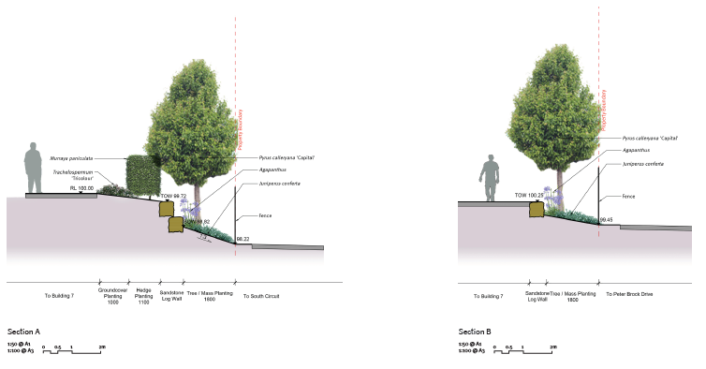
Figure 8: Section of terrace style plantings

(c) the suitability of the site for the development

As demonstrated by the above assessment, the site is considered to be suitable for the proposed development.

(d) any submissions made in accordance with this Act or the regulations

The DA was publicly exhibited for a period of 14 days in accordance with Camden Development Control Plan 2019. The exhibition period was from 15 January 2020 to 28 January 2020. No submissions were received.

(e) the public interest

The public interest is served through the detailed assessment of this DA under the Environmental Planning and Assessment Act 1979, the Environmental Planning and Assessment Regulation 2000, environmental planning instruments, development control plans and policies. Based on the above assessment, the proposed development is consistent with the public interest.

EXTERNAL REFERRALS

The external referrals undertaken for this DA are summarized in the following table:

External Referral | Response
Transport for NSW (formerly Roads and Maritime Services.) | No objection and no recommended conditions.

FINANCIAL IMPLICATIONS

This matter has no direct financial implications for Council.

CONCLUSION

The DA has been assessed in accordance with Section 4.15(1) of the Environmental Planning and Assessment Act 1979 and all relevant instruments, plans and policies. The DA is recommended for approval subject to the conditions attached to this report.

RECOMMENDED
That the Panel approve DA/2019/987/1 for a new school building at 60 Central Avenue, Oran Park subject to the conditions attached to this report.

